Haron Computer P.L.C

MarakiPOS - Odoo ERP Integration

Document

To: Bekas Chemicals PLC
Addis Ababa, Ethiopia

Date: Feb 2, 2026

1. Objective
This document aims to outline the implementation framework for integrating Maraki POS with two distinct Odoo ERP server instances hosted in different physical locations, with the goal of achieving seamless and reliable data synchronization.

2. Scope of Integration

2.1 System Architecture
From the system architecture perspective, to independently integrate each Odoo ERP server with its corresponding Maraki POS system, we plan to implement a branch-based server-to-POS integration approach. This method will allow us to manage and maintain each server–Maraki POS integration separately, ensuring better scalability, easier troubleshooting, and improved system reliability.
As part of the integration process, we will require a single dedicated integration user account from your side. The provided credentials will be securely stored after being hashed, ensuring enhanced security, confidentiality, and reliability of the integration over internet-based communication

2.2 Sales Flow Architecture (Integration Types)

We plan to implement the integration in two phases:
- Phase 1: Focus on Scenario 1 – Sales initiated from Odoo ERP, ensuring that sales orders created in ERP are transmitted to Maraki POS, receipts are generated, and transaction status is synchronized back to ERP. This phase will be fully tested before proceeding to phase 2.
- Phase 2: Implement Scenario 2 – Sales initiated from Maraki POS, enabling POS transactions to synchronize with Odoo ERP when it becomes available.

3. Key Integration Requirements
To successfully implement the integration with near real-time, two-way synchronization between Maraki POS and Odoo ERP in two phases, we require the necessary APIs and corresponding data, all of which must be provided in JSON format. Even though we include Phase 2-related details, this document mainly focuses on Phase 1 implementation. ,

3.1 Required API’s
To complete the first phase (Sales Initiated from Odoo ERP) of the integration, we require three APIs, described as follows:
- Get Sales List API: This API is responsible for returning the latest sales orders that are ready for processing by our system. This API should not return any sales which is already sold.
- Get Sales Detail API: As the name suggests, this API provides detailed information related to a sale, including customer data, items, taxes, and other relevant details, as explained in the next section.
- Set Sales Status API: This API updates the sales status in Odoo ERP by receiving the necessary information from Maraki POS.
For the second phase (Sales Initiated from Maraki POS) of the integration, we require the following APIs, described as follows:
- Request for Syncronization API (not mandatory): It would be better to have an aPI, which initiates the synchronization of sales from Oddo ERP to make things simple and precise. If this is not possible, we will use other alternatives to replace this API request using Cron Jobs.
- Get Last Sync Sales API: To eliminate the duplication of sales, we want to confirm whether our last sync time and sales id are similar to the Odoo ERP
- Sync Sales API: After checking the last sync time and invoice id, we will send all those sales performed without the presence of Odoo ERP to seamlessly sync the sales data.

3.2 Required Information’s
The information we require from your system is organized by category, as detailed below:
- Products (Items): The attributes we require for the products (items) to proceed with the transaction successfully include the following:
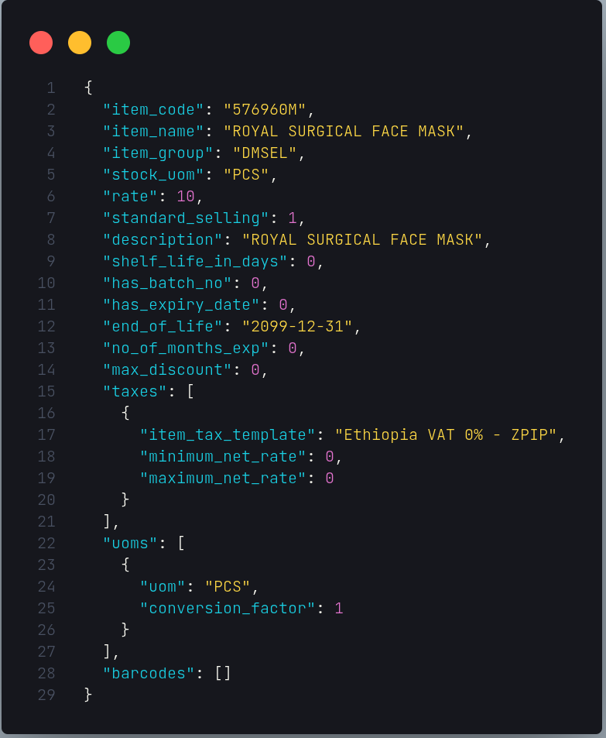
- Customers: for the individual customers, the address and contact list may not be mandatory. In addition, TIN, Operate on multiple locations, Sub TIN, and Tax Withholding Category are also not mandatory for individual-type customers.
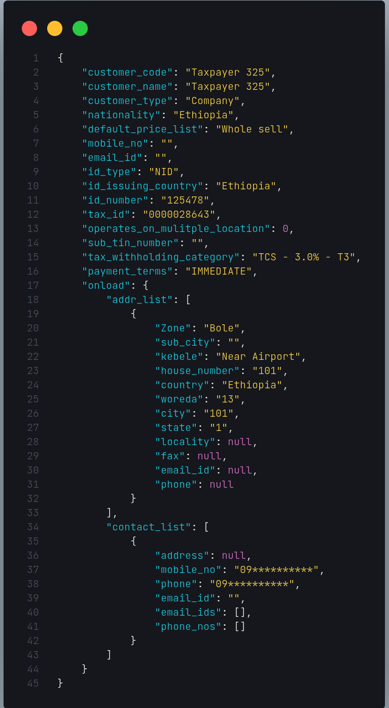
- Item Prices:
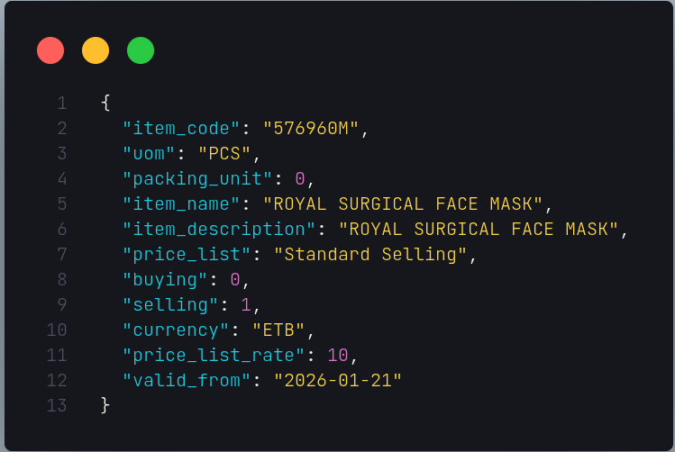
- Payments: In the payments section, we require the mode of payment and the amount to be paid when completing the transaction.
- Sales Transactions: From this section, we expect all the above segmented information to be consolidated into a single sales transaction record, along with additional computed values such as pre-tax total, total tax, grand total, rounded total, paid amount, total discounts, and outstanding amount.

👉 Any Phase 2-related data formats will be prepared by your side to prepare our API’s reponse accordingly.

4. Error Handling and Logging Information
In the event of any errors, the POS system will display an appropriate and user-friendly message to the user. All critical operations and inter-system communications will be logged within our system to ensure traceability and to help identify and resolve any discrepancies between the integrated systems.

5. Expected Outcome
To ensure the expected outcomes are met, we expect your system to return only non-sold (open) sales when sales lists are requested. In addition, any sales marked as completed based on the status received from your API will be excluded and not allowed for further processing from our side.

5. Integration Time Plan
We expect there is a dedicated team to do this integration from the Bekas Chemicals PLC, which makes the time plan more realistic and attainable. But from our side, after getting phase 1 disscussed API’s, we will finish the integration in two weeks (14 days), the first seven (7) days for implementation only, and the next seven days for pilot testing and production release.

👉 This time plan does not include the Phase 2 implementation. If we need to prepare the time plan for this phase, we need to get a full common understanding of it, including the data attributes expected from our system by the Odoo ERP.
👉 Note: Any change initiated by the Ministry of Revenue will be addressed by both parties.

